LED Specifications

* 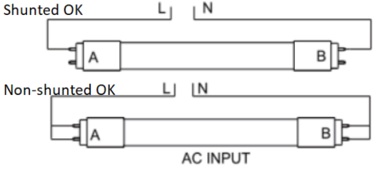Our Light Tube LEDs are double ended and is ballast compatible. We choose to build our structure with a ballast to decrease initial setup cost, maintenance and replacements. Since it is a straight up swap and replace.
* Double ended tube lights are compatible with shunted and non-shunted tombstones.
* What is needed in an LED Grow Light
  + 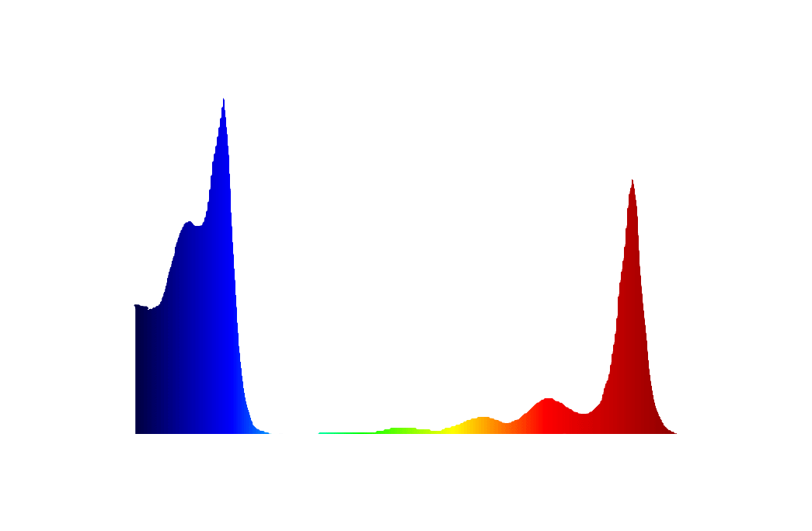Purpose? Deliver necessary light to plants so that it can perform photosynthesis tand grow quickly and healthy
  + Chlorophyll A
    - Has peaks in red and blue
    - 380 – 450 nm are absorbed well, peak at 430nm
      * 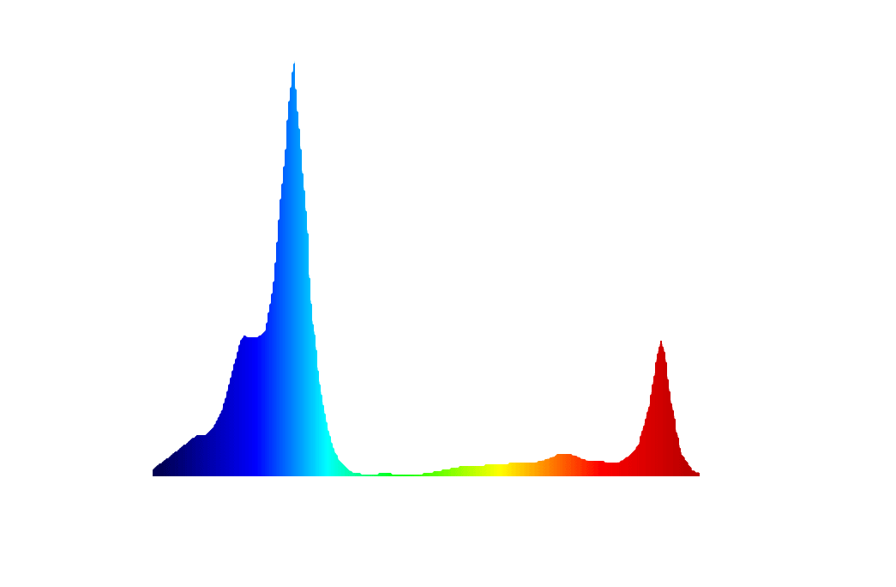In red, 600nm and above are absorbed with peak 660nmThis tells us that providing light at 430 nm and 660nm will allow chlorophyll A to very efficiently convert photons into energy for plant
  + Chlorophyll B
    - Peaks in red and blue, but absorbs blue more efficiently
    - Peak at 450nm dominates in blue, at red peak is 640nm
  + Blue and red works best for photosynthesis, especially 430m 450, 640 and 660nm.
  + 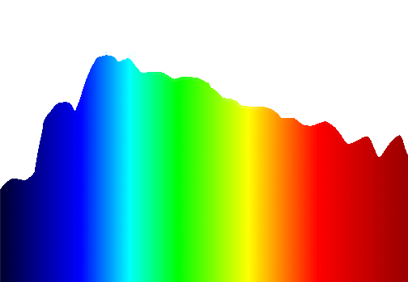It is still critical that plants absorb light from all colors of spectrum, but adding more red and blue ca increase its growth
  + Natural Daylight is extremely healthy for plant growth:
    - Summer: equal all around
    - 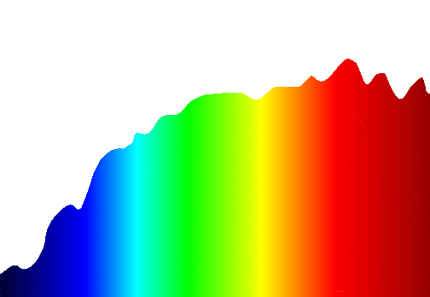Fall: Due to lower angle of the sun, red and orange regions hv more energy. That’s why certain flower and fruits grow during this period.
  + Intensity
    - Each plant need different Daily Light Integral (DLI)
      * Typically, lettuce and spinach need 5-10 DLI
      * High light plants usually upwards of 20 DLI
  + Generating White Light for full spectrum (what plant needs for balanced growth, not just quantity, but also quality).
    - White emitting lights doesn’t mean it’s a full spectrum
    - A full spectrum (natural light) consists of wavelength from infrared - ultraviolet
    - Using phosphor coating
      * Takes light from single narrow wavelength and convert it to a wide range of longer wavelength.
    - Measure CRI, higher CRI rating indicates it is more similar to natural daylight (most ideal)
  + Optimal Distance?
    - LEDs don’t generate infrared, so even at close proximity, plants generally wont suffer burns or tissue damage, but they DO generate LITTLE heat, and its casing can get very warm. Keep a little distance away.
  + Photosynthetic photon flux (PPF – umol/s), measures light from single light source, beam angle affects
  + Photosynthesis photon flux density (PFD – umol/s/m2), how much light hits plant
    - Can be combined from other lights
    - Distance and location effects this
    - We can calculate DLI from this using time
      * Low light requirement plants = 5-10, med = 10-15, high = 15+’
  + Achieving Full Spectrum (natural Light)
    - Natural daylight has even distribution of all wavelengths across visible spectrum
    - Truly full spectrum light sources must have high CRI and color temp between 4000K and 6500K (a 99 CRI would be indistinguishable from daylight)
    - 1: Waveform Lighting 99 CRI, closest to natural light, 2: natural Light
      * 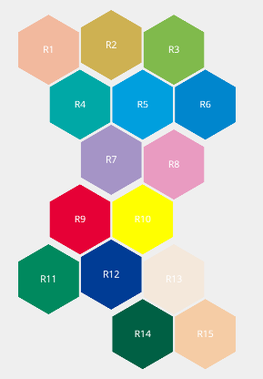So what is high CRI? (max 100)
      * 95> is very high and would make objects appear very similar to how they would look under natural lighting conditions
        + CRI has smaller subscores: R values (each has max 100), each R value represents the light sources color rendering ability for a particular color/shade.
        + CRI Ra is the average of first R8 values
        + 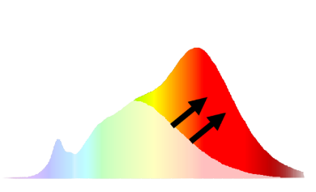Recipe: most richest vivid colors we see require red wavelength to be revealed. In natural light there is a lot of red wavelength, but not most efficient for illumination, so red light is decreased in most LEDs in exchange for green because it has higher efficacy. Then we incorporate additional high efficiency red phosphor in LED manufacturing process to improve spectral composition and create white light closer to natural light.
    - 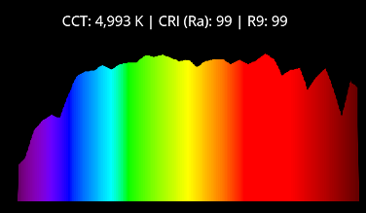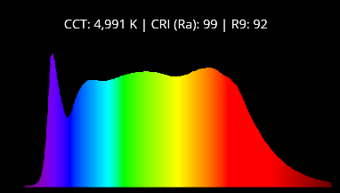phosphor coating converts light energy of one wavelength and redistribute that energy as different wavelength (red phosphor would convert blue light and reemit red)
      * Because LED phosphors are in powder form, they can be mixed with other various color recipes with changes in phosphor ratio resulting in subtle color differences
* Measurements:
  + Correlated Color Temp (CCT); color of tubes depends on Temp, lower is cooler (blue), higher is hotter (yellow) normal is white (X)
  + Luminous Flux; measure in lumens, measures how much light is emitted from light (to measure brightness)
  + Color Rendering Index (CRI); measures the extent to which objects color appear true and accurate under light source. For enhanced color quality where color perception is important, higher CRI is important
* Products (all can simulate natural sunlight):
  + PhotonTube T5HO LED (Rated Life 40k Hours)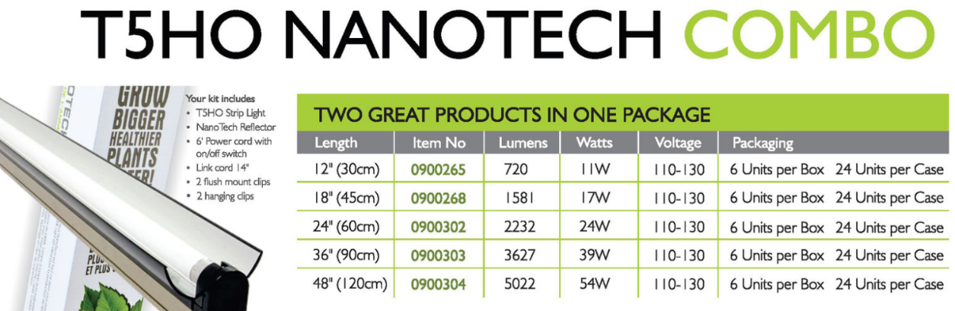, $180 for 4
    - Photosynthesis outputs peak between 435 nm and 680 nm, 6400K have relative intensity peaks at 435 nm and 615nm making it ideal for propagation and long-term growth.
    - Though it can provide light for full term growth, it is best for seedlings and cuttings (root development)
    - Ensures optimum light spread and diffusion across growing area and does not need to be rotated and the likes
  + PhotonTube T8 LED (Rated 50k Hours) $139 for 4
    - Length 48 inches (120cm), 1-inch lamp diameter, also have 8ft tubes (240cm)
    - Well suited for seedlings and vegetative growth
    - V: 120, 208, 240, 277 V AC
    - Double ended, any/no ballast, works shunted and non-shunted tombstones
    - Watts: 18W
  + PhotonPanel, 149$ per panel
    - Size: 30 x 60 cm
    - DLI of 30+ for 16 hours per day
    - Watts: 108W per panel
    - Special features: redboost (chlorophyll optimization with wide red coverage (650 & 730nm)
    - Need 24V power supply (separate)
  + Photon 2k series (Rated 50k Hours) 2100 n 2200 (295$ & 475$ for 1)
    - * Waterproof for greenhouses and grow tents
        + Good for big plants
      * Optimized emission spectrum to match chlorophyll A and B absorption curves.
      * Watts: 100W and 200W respectively
        + Size2100: 27 x 16.5 x 16 cm, 100 – 270V
        + Size2200: 27 x 33 x 24.4 cm, 100 – 270V

Crops

* Corn
  + Limiting factor is light, especially light reaching the lower canopy, which correlates to seed yield
  + Same lighting that produces excellent vegetative growth does not product adequate seed yield if plants are too close
  + Minimum distance between stalks should be 30.5cm (due to corn needing light at the bottom, unless we have enough lights at the top to cover the bottom, we can decrease the distance).
  + Higher DLI = closer distance = more corns
  + Twin-row configuration: 2 rows spaced so that stalks in each row are 30.5cm apart (inter-row is same spacing), then 76-91 cm between stalks and those of the next twin row.
  + Supplemental light is not necessary for optimum seed production, it will need light at ranges of 250-750 umol/m2/s at 1 meter below lights (sunlight/ greenhouse)
    - Without sunlight, they are capable of 500-2000 umol/m2/s
    - Lamps are usually mix of metal halide with high pressure sodium or only metal halide
  + Humidity of room/ space must be kept above 40% when using high supplemental light intensity
  + Being too close to lights might kill pollens
  + Photoperiods of about 14-16 hours average and 20 hours on vegetative phase
    - Or 16 for all stages
    - 24 hours results in calcium deficiency symptoms on corn seedlings and damages leaves
  + Corns have a critical window where they need lots of light (for about 2-3 weeks)
    - We could have a light system that go up and down to maximize lights
    - Initially, u want light to be close and after stalks grow the light will keep moving back until about 1 meter.
      * We could remove tassels after pollination so that we can have lights closer during grain-fill period
  + It is suggested: 1.5 moles/day at lowest leaf
    - Which is 30 umol/m2/s for 14 hours per day at that height
    - A 150 umol/m2/s one meter below lights in glass greenhouse, people could achieve 1.7-4.4 moles/day at lowest leaf for seven days during seed ripening stage. (which is good = good seed yield of 583 seeds/ear, but they abort secondary ears).

